How to Create Windows Password Recovery USB Drive

Article Source:

http://recoverlostpassword.com/article/create-windows-password-recovery-USB.html

What is USB Drive?

A USB drive, also known as a flash drive or keychain derive, is a plug-and play portable storage device that consists of a flash memory with a USB interface and is physically much smaller than a floppy disk or CD-ROMs. Due to its smaller size, faster transmission rate, more capacity, more durable and reliable, most desktop and laptop computers in favor of USB drive

Except storing and transferring data, a USB drive is usually used to create Windows Password Recovery USB flash drive, which can help to reset windows password easily and effective when you lost or forgot windows login password.

Note: Creating Windows Password Recovery USB drive relies on windows password recovery software, if you don’t want to use such kind of software and you are foresighted have made a password reset disk for your computer login account, it will be easy to reset the forgotten windows password.

Otherwise, if you forgot the password now and do not prepare a password reset disk before, you also not need to worry so much, just follow the detail steps below to create a Windows password recovery USB drive.
Compare with three different version of windows password recovery software which was released by SmartKey working team.
Windows Password Recovery Standard: reset lost or forgotten Windows administrator password and other user account passwords with a bootable CD/DVD

Windows Password Recovery Professional: reset lost or forgotten Windows administrator password and other user account passwords with a bootable CD/DVD or USB Drive Flash

Windows Password Recovery Enterprise: reset lost or forgotten Windows local account or Domain Administrator password with a bootable CD/DVD or USB Drive Flash

So, if you only have a USB flash drive, choose the Professional or Enterprise version to create a Windows password reset USB.

Below are the steps to create a windows password recovery USB using Windows Password Recovery professional.
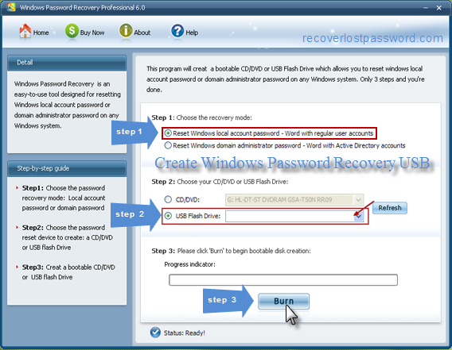
Step 1: Download and install Windows Password Recovery Professional in any available computer.
Step 2: Run the software and insert a USB flash drive into a USB port on your computer.
Step 3: Select “USB flash drive” and then click “Burn” to burn a Windows password recovery USB drive.
Step 4: When the burning process finish, click “OK” to complete the burning process.
Now you can use your newly created Windows password recovery USB to remove or reset forgotten windows password.

